2 December 2013

Harry’s Shed uses wood to unlock the world for people who are blind or have low vision
Guy Sands, from Concord, didn’t have the slightest idea how people with vision impairment learn to read braille until his local men’s shed, Harry’s Shed, also known as the City of Canada Bay Men’s Shed Inc was approached by Vision Australia to make some braille blocks.  Four weeks later 58 boards were delivered to Vision Australia’s Sydney head office in Enfield.  “It was a really interesting project. My previous training was a wool classer and I have fairly sensitive fingers, but I think it would be really hard to train your hands to feel the dots in braille,” says Guy. “It is amazing how people can train their sensory touch to be able to pick up this sort of information,” he added.  As part of the process of teaching braille, Vision Australia provides clients with a braille block.  This small timber device has six holes into which six short pieces of timber dowel can be inserted and removed to create the 64 unique combinations required for grade one braille.  “It is crucial for beginners to practice recognising the letter combinations by familiarising themselves with the various grid arrangements,” says Kathy Fela, Team Manager at Vision Australia.  The lacquered boards were made with rosewood bases and pine dowels. Each board enabled each letter of the alphabet to be represented by a different combination of raised and lowered dowels.  “The boards were beautifully made”, said Ms Fela. “They are invaluable in the early stages of teaching touch recognition of both letters of the alphabet and numbers.”  It was a team effort at the Shed. Stephen Liddicoat did the band-sawing, Guy machine-sanded the bases and Norm Shopland and Harold Pedley, did the fiddly bits. Bob Arrow and Norm Tate helped out where needed.  To find out more about Harry’s Shed or to join call 9745 6962 or drop in to 1a Gipps Street Concord. | - Local men’s shed creates braille boards for Vision Australia  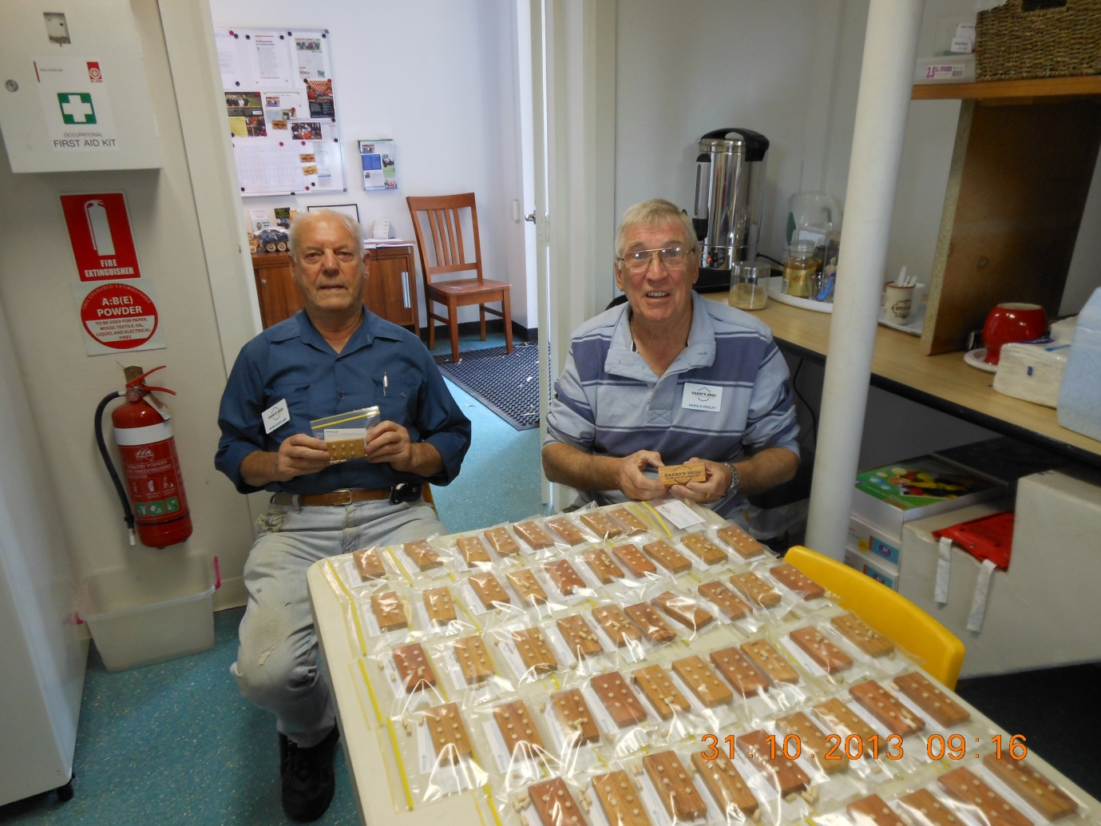  Norm Shopland and Harold Pedley with the boards
Combining the skills and resources of several leading blindness organisations to create one national voice, Vision Australia is committed to delivering exceptional and efficient services that open up exciting possibilities for our community. For more information or to support Vision Australia call 1300 84 74 66 or visit www.visionaustralia.org.

